AssistX-AI Powered Voice and Gesture Controlled Cursor
K. Durga Kalyani¹, a) Chidurala Mounya Sai², b) Pulimamidi Navya², c) Boddepalli Sravan Kumar²
¹ Assistant Professor of CSE, GCET, Hyderabad, TS, India.
² Student, Department of CSE, Geethanjali College of Engineering & Technology, Hyderabad, TS, India

ABSTRACT
Human–computer interaction has improved significantly with the growth of artificial intelligence and computer vision technologies. Traditional interaction mainly depends on physical devices such as a mouse and keyboard, which may not be convenient for elderly users or individuals with physical disabilities. To overcome these limitations, researchers have explored alternative interaction methods such as gesture recognition, voice control, and multimodal systems that enable more natural communication between humans and computers.
This paper proposes AssistX, a multimodal human–computer interaction system that integrates hand gesture recognition and voice commands to control a computer interface. The system uses a webcam to detect hand movements and a microphone to capture voice instructions, removing the need for expensive hardware. By combining computer vision and speech recognition techniques, the proposed system provides a simple, accessible, and efficient way for users to interact with computers in a touch-free manner.
Keywords
Human Computer Interaction, Gesture Recognition, Virtual Mouse, Voice Assistants, Computer Vision, Multimodal Interaction
INTRODUCTION
Human–computer interaction (HCI) is an important part of modern computing. Traditional interfaces rely on devices like keyboards, mice, and touchpads, but these can be difficult for people with mobility limitations or in situations where touching hardware is inconvenient. Recent advances in computer vision and artificial intelligence have enabled more natural interaction methods, such as gesture recognition, where hand movements are interpreted as digital commands [7][8].
Many researchers have developed virtual mouse systems that use cameras to track hand gestures and convert them into actions like clicking, scrolling, or dragging. However, several existing systems depend on specialized hardware such as depth-sensing cameras, which increases the cost and complexity of implementation [1][3][4][5].
Another key area in HCI is voice-based interaction through intelligent assistants. Voice commands allow users to control computers using natural language, which is especially helpful for elderly users and people with disabilities. To improve usability, modern research focuses on multimodal interaction, combining inputs like gestures and voice. Based on this idea, the proposed system, AssistX, integrates gesture recognition and voice commands to provide an intuitive and accessible way to control computer interfaces using common devices like webcams and microphones [2][6][7][8].
RELATED WORK
Table 1: Recent Research Papers on Gesture and Voice-Based Cursor Control Techniques
Year | Authors | Title | Methodology | Limitations
2025 | Chunling Yu | Gesture Recognition with YOLOv5 | Deep learning object detection | High computational requirements
2024 | Bokolo Anthony | AI Voice Assistants for Mobility | Voice interaction systems | Limited gesture integration
2024 | Birkeland et al | Thermal Gesture Recognition using CNN | Thermal camera and CNN model | Thermal cameras are costly
2023 | Todericiu | Virtual Assistants Review | Overview of voice-based AI assistants | Limited multimodal capability
2020 | Vojtech et al | Head-Tilt and EMG Cursor Control | Head movement and EMG signals | Needs specialized sensors
2020 | Tran et al | Real-Time Virtual Mouse System Using RGB-D Images | Fingertip detection using depth cameras | Requires expensive RGB-D sensors

PROPOSED METHOD
The proposed system develops a multimodal human–computer interaction system that enables users to control the computer cursor using hand gestures and voice commands. Traditional input devices like a mouse and keyboard may not always be convenient, especially for users with mobility limitations or in touch-free environments. To address this, the system integrates computer vision and speech recognition technologies to provide a more natural way of interacting with computers. The system uses a webcam to detect hand gestures and a microphone to capture voice commands. Image processing techniques track hand movements for cursor control, while speech recognition interprets spoken instructions. By combining gesture and voice inputs, the system allows users to perform actions such as cursor movement, clicking, scrolling, and opening applications without physical input devices, improving accessibility and user experience.
Workflow
- User Input The system begins when the user interacts through hand gestures or voice commands. The webcam captures real-time hand movements, while the microphone records voice commands such as “click”, “scroll”, or “open” for further processing by the system.
- Pre-Processing Before recognition, the input data is prepared for analysis. In visual processing, the system captures webcam frames continuously, resizes and filters them to reduce noise, and detects the hand region for gesture recognition. In audio processing, voice signals are captured through the microphone, noise is reduced using filtering techniques, and important speech features are extracted for command recognition.
- Gesture Recognition The system analyzes hand movements using computer vision algorithms. Hand landmarks are detected using models such as MediaPipe, and fingertip positions are tracked to identify gesture patterns. These gestures are then mapped to cursor actions such as cursor movement, left click, right click, and scrolling.
- Voice Command Recognition Voice commands are processed using speech recognition, where audio signals are converted into text and commands such as click, scroll, open browser, or close window are identified and mapped to the corresponding system actions.
- Multimodal Integration Both gesture and voice inputs are integrated into one control system. Gestures are used for cursor movement and basic actions, while voice commands handle higher-level tasks like opening applications. The system also verifies commands to avoid conflicts between gesture and voice actions.
- Cursor Control and System Action After interpreting the inputs, the system updates the cursor movement on the screen, performs mouse actions such as click, drag, and scroll, and executes applications or functions based on voice commands.
- Continuous Learning and Improvement The system continuously improves its performance through dynamic learning and user feedback. Machine learning models adapt to different users and environments, while user feedback helps refine gesture recognition and voice command accuracy.
Testing and Evaluation
The system is tested under different users and environmental conditions to evaluate its performance. Key metrics include detection accuracy, which measures how correctly the system recognizes gestures and voice commands, response time, which indicates how quickly the system detects and executes commands, and user experience, which evaluates how easy and convenient the system is for users. The proposed system is also compared with existing approaches such as gesture-only systems, which rely only on camera-based hand gestures, and voice-only systems, which depend solely on speech commands. This comparison helps demonstrate the advantages of the multimodal approach in improving usability and interaction efficiency.

Challenges
Some limitations were observed during testing. Poor lighting conditions can reduce gesture recognition accuracy, background noise can affect voice command recognition, and differences in hand shapes, accents, or speaking styles may influence overall system performance.
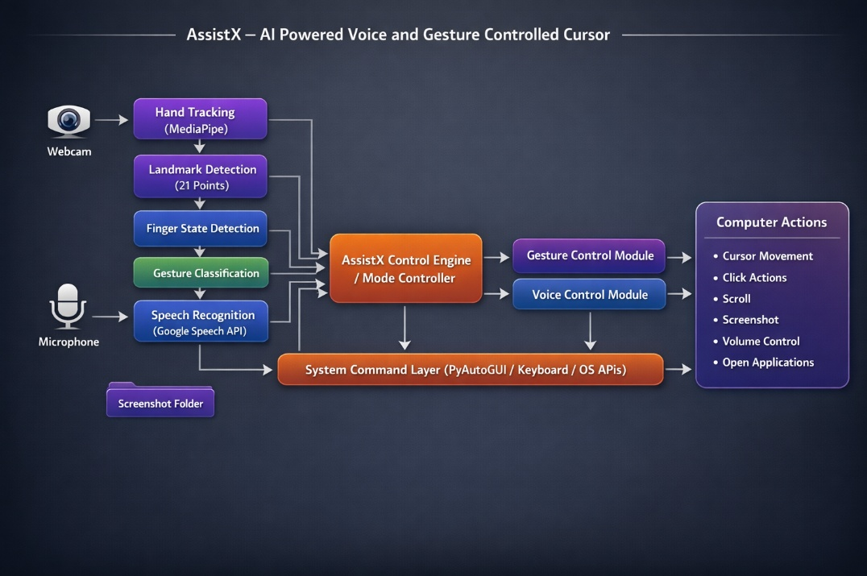
Figure 1: System Architecture

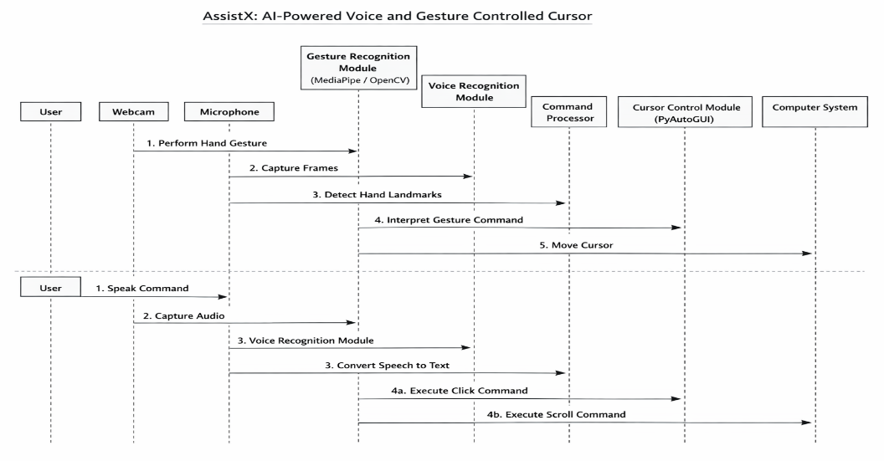
Figure 2: Process Sequence
IMPLEMENTATION
Table 2: Proposed Work Using Libraries and Models
Component | Type | Purpose | Description
OpenCV | Library | Image processing and video capture | OpenCV is used to capture webcam video and process image frames for detecting and tracking hand gestures used to control the cursor.
MediaPipe | Framework | Hand landmark detection | MediaPipe uses pre-trained models to detect and track hand landmarks, helping recognize gestures for cursor control and actions.
PyAutoGUI | Library | Cursor control and automation | PyAutoGUI is used to control the mouse cursor and perform clicks based on gestures or voice commands.
SpeechRecognition | Library | Voice command processing | SpeechRecognition converts spoken voice commands into text so the system can understand and execute actions.
Python | Programming Language | System development | Python is used to develop the system and integrate libraries for gesture and voice-based cursor
Table 3: Module Analysis
MODULES | PURPOSE | DESCRIPTION
Gesture Detection | Identifies hand landmarks using MediaPipe | This module captures webcam frames and uses MediaPipe to detect hand landmarks, enabling real-time gesture recognition.
Cursor Control | Maps finger movements to cursor movement | After detecting hand landmarks, the index finger position is mapped to screen coordinates to move the cursor without touching the mouse.
Click Detection | Recognizes finger gestures for mouse clicks | Pinching the thumb and index finger is detected as a gesture and translated into mouse actions such as left-click / right-click.
Voice Command Recognition | Converts speech to commands | The microphone captures voice input, and the speech recognition module converts spoken words into text commands for system execution.
Command Execution | Performs system actions | Recognized gestures or voice commands are executed by the system using PyAutoGUI to perform actions like clicking, scrolling, and cursor control.

Table 4: Output Analysis
Module | Purpose | Output
Gesture Detection | Detects and tracks hand landmarks using MediaPipe and webcam input. | Hand landmark coordinates and gesture patterns identified from the video frames.
Cursor Control | Converts detected finger movements into cursor movement on the computer screen. | Smooth cursor movement that follows the user’s finger position.
Click Detection | Identifies specific finger gestures that represent mouse actions. | Mouse click events such as left click, right click, or double click executed on the system.
Voice Command Recognition | Captures and converts spoken commands into machine-readable text. | Recognized text commands such as “click”, “scroll”, or “open”.
Command Execution | Processes the recognized gesture or voice command and performs the required system action. | System operations performed such as cursor movement, clicking, scrolling, or executing commands.
RESULTS AND DISCUSSION
The AssistX system achieved reliable cursor tracking using gesture recognition under normal lighting conditions. The voice recognition module successfully converted spoken commands into system actions, allowing users to control the computer without physical interaction. The system improves accessibility by enabling users to use either gesture control or voice commands. Additionally, AssistX works with standard hardware such as webcams and microphones, reducing the need for expensive or specialized devices.
The integration of gesture and voice interaction enhances usability compared to systems that rely on only one input method. Users can switch between gestures and voice depending on convenience and environmental conditions. However, system performance may be affected by poor lighting or background noise. Future improvements may include advanced deep learning techniques to improve gesture detection accuracy and more robust speech recognition in noisy environments.
CONCLUSION
This research presents AssistX, a multimodal human–computer interaction system that integrates gesture recognition and voice commands to create a natural and accessible way of controlling computers. The system demonstrates how artificial intelligence and computer vision can replace traditional input devices like the mouse and keyboard by enabling touch-free interaction through hand gestures and voice instructions. Unlike many existing solutions that require specialized hardware, AssistX works with commonly available devices such as webcams and microphones, making it practical and cost-effective. Future improvements will focus on enhancing gesture detection accuracy using advanced deep learning techniques and expanding the system with additional interaction methods such as facial expression and eye-tracking support.

REFERENCES
[1] D.-S. Tran, N.-H. Ho, H.-J. Yang, S.-H. Kim, and G.-S. Lee, “Real-Time Virtual Mouse System Using RGB-D Images and Fingertip Detection,” Multimedia Tools and Applications, 2020.
[2] J. M. Vojtech, S. Hablani, G. J. Cler, and C. E. Stepp, “Integrated Head-Tilt and Electromyographic Cursor Control,” Boston University, 2020.
[3] A. A. Argyros and M. I. A. Lourakis, “Vision-Based Interpretation of Hand Gestures for Remote Control of a Computer Mouse,” Springer, 2006.
[4] S. Birkeland, L. J. Fjeldvik, N. Noori, S. R. Yeduri, and L. R. Cenkeramaddi, “Thermal Video-Based Hand Gesture Recognition Using Lightweight CNN,” Journal of Ambient Intelligence and Humanized Computing, 2024.
[5] C. Yu, “Computer Interactive Gesture Recognition Model Based on Improved YOLOv5 Algorithm,” Springer, 2025.
[6] B. Anthony Jnr., “User-Centered AI-Based Voice Assistants for Safe Mobility of Older People in Urban Context,” AI & Society, 2024.
[7] I. A. Todericiu, “Virtual Assistants: A Review of the Next Frontier in AI Interaction,” Universal Access in the Information Society, 2023.
[8] I. A. Todericiu, “Multimodal Human–Computer Interaction Systems: Recent Trends and Challenges,” Springer, 2024.
[9] D. Afchar, V. Nozick, J. Yamagishi, and I. Echizen, “MesoNet: A Compact Facial Video Forgery Detection Network,” IEEE, 2019.
[10] B. Dolhansky et al., “The DeepFake Detection Challenge Dataset,” NeurIPS, 2020.
[11] P. Korshunov and S. Marcel, “DeepFake Detection Using Audio Visual Information,” IEEE Biometrics Conference, 2019.
[12] Z. Liu and W. Xu, “Audio Visual DeepFake Detection Using Multimodal Learning,” IEEE Transactions on Multimedia, 2021.
[13] H. Nguyen, F. Fang, J. Yamagishi, and I. Echizen, “Multi Task Learning for Detecting and Segmenting Manipulated Facial Images and Videos,” IEEE, 2019.
[14] Y. Li and S. Lyu, “Exposing DeepFake Videos by Detecting Face Warping Artifacts,” IEEE CVPR Workshop, 2018.
[15] T. Jung, S. Kim, and K. Kim, “DeepVision: Deepfake Detection Using Deep Learning Techniques,” IEEE Access, 2022.

